APPLIED INFORMATION TECHNOLOGY

Week 3 Term 2 Evaluation Test
- Name:
SOLUTIONS
Save all images to this document
- Save this document as your initials _Assessment1.doc and place this in your AIT Marking Folder

Use the highlighter to mark your multiple choice answers
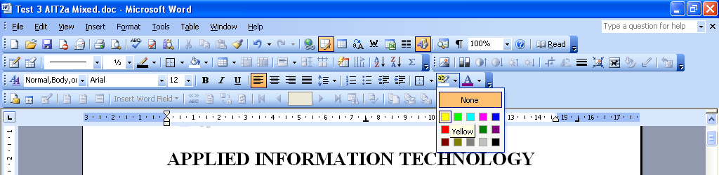

Part 1 Multiple Choice Part 2 Short Exercises

Time allowed for this paper One lesson

Material required : computer

Time recommended for this assessment: one lesson

Important note to candidates
No talking

No other items may be taken into the examination room. It is your responsibility to ensure that you do not have any unauthorised notes or other items of a non-personal nature in the examination room. If you have any unauthorised material with you, hand it to the supervisor before reading any further.

Evaluation Test Starts next page

Part 1 Multiple Choice
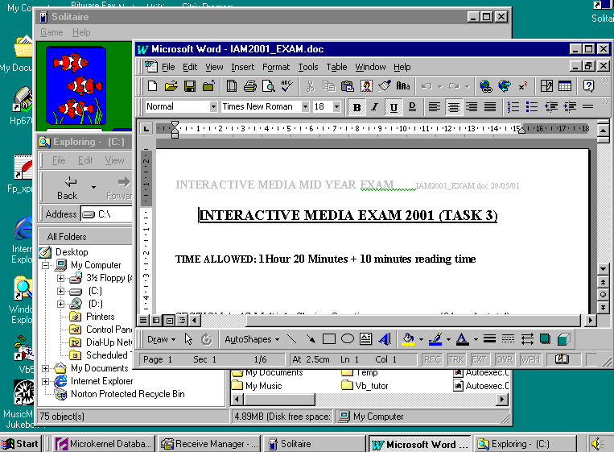
1. Shown is a screen shot from a personal computer. How many programs does the user have available on the desk top according to the picture?
a) 7
b) 6
c) 5 see Task bar
d) 4

2. According to what you can see on the screen dump, how many windows are open on the desk top?
a) 4
b) 3 Word, Solitaire and Explorer
c) 2
d) 1

3. If an Adobe Photoshop image cannot be used by another application, how could you fix this?
- EXPORT or SAVE AS an acceptable file type
- Email it to the teacher and they will fix it and email it back to you
- EXPORT or IMPORT into PDF, depending on what format you want
- SAVE as .doc and then use it as a graphic

4. What is the primary reason a good web designer would keep digital images small on a web-site?
- They are easier to see on the screen
- It is easier to read the text next to them
- They will allow the page to load faster because of the smaller file sizes
- They make the presentation look far more professional

5. Which resolution offers the best economical and acceptable quality for a screen presentation?
- 96 dpi
- 600 dpi
- 72 dpi
- 3000 dpi

6. Which of the following series contains only possible audio file formats?
- .midi, .aud, .wav, .pdf
- .mp3, .aud, .midi, .wav
- .mp3, .bmp, .wav, .mp4
- .jpg, .mov, .mp3, .wmp

7. You have found a site that really interests you on the ‘net’. What should do to remember where the location of this site is so that you can visit it at a later date?
(a) Write it in your diary
(b) Make a note in notepad
(c) Save it as a bookmark or favourite
(d) Tell your friend and hope they remember it

8. What colours are used in each pixel in a colour graphics display?
(a) Red, Green and Blue
(b) Cyan, Magenta and Yellow
(c) Cyan, Magenta, Yellow and Black
(d) Red, Green and Black

9. What does URL stand for?
(a) University Resource Location
(b) Universal Resource Locator
(c) Unlimited Resource Locator
(d) Unusual Resource Locations

10. What resources do you need to be able to access the Internet?
(a) A computer, with web browser software.
(b) A laptop computer, web browser software and an Internet provider.
(c) A computer, a modem, communications software and an Internet provider.
(d) A computer, a modem and an Internet service provider.

END OF MULTICHOICE

Part 2 Short Exercises

Topic: COMPUTER GRAPHICS - PRACTICAL

Use your computer graphics package to create the following: save your images on this page

(Note: the graphics do not have to be the same size as the ones shown but should be approximately in the same proportion)
1 Boxes

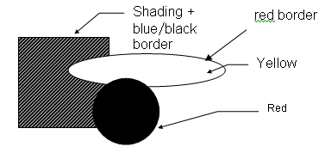
(a)

8 marks

Save your image here two samples shown

2.Exit
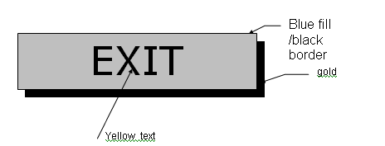

5 marks

Save your image here two sample shown
EXIT

EXIT

3.Box
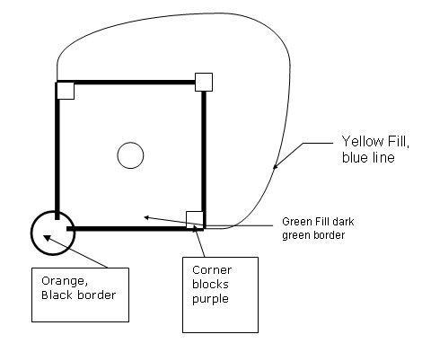

5 marks

Save your image here two samples shown
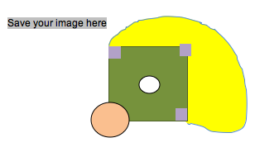

Images can be found on the shared student drive in the AIT folder

Using an appropriate software package
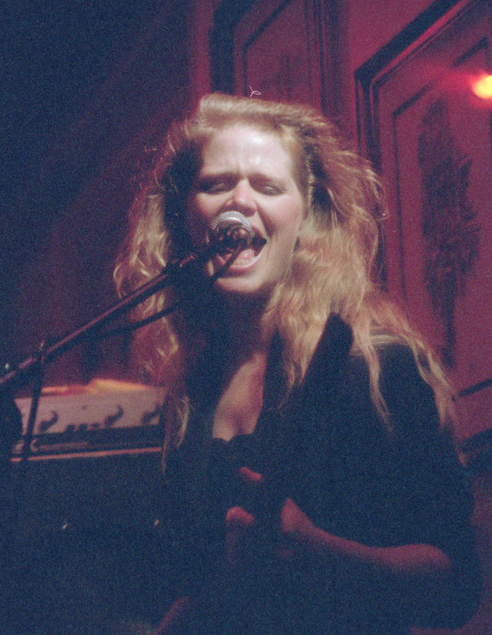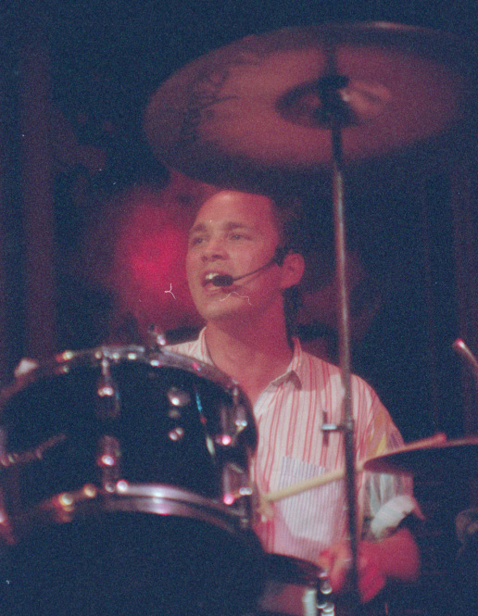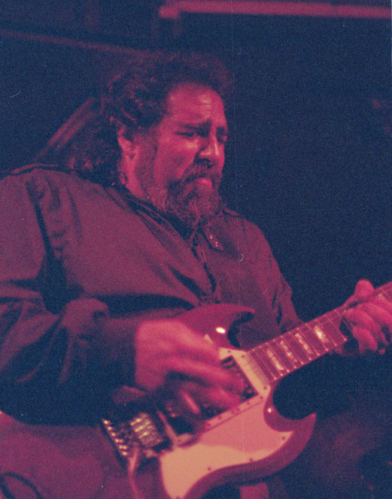

4.Merge the three images into one image saved as your intials_my band.jpg
Insert your completed image here: two samples shown
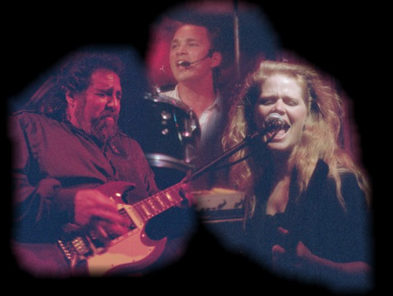



Save all the images back onto this document

- Take this image and Square up the tilt so that the image is horizontal
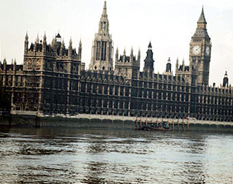

Save the image back onto this document

- Improve the colour of this photograph back to a natural colour
Save the image back onto this document
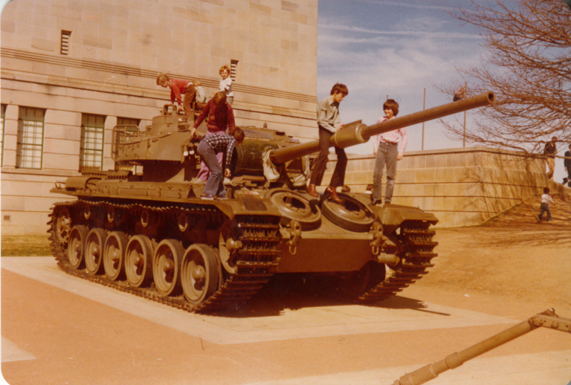
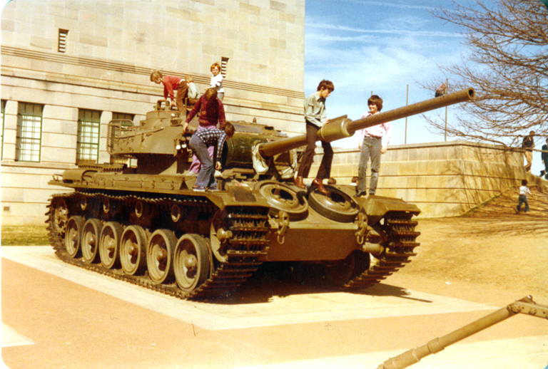

- Remove the background colour of this photograph so that the image is on a white background
Save the image back onto this document



- Replace the airborne boy with a picture of the aircraft “air france.jpg” (from MyClasses) ensure you use appropriate scale and size to suit the picture content.
Save the image back onto this document
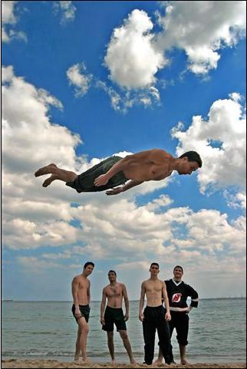

Note if you select another aircraft from the
Power point (low aircraft.ppt) you will obtain a
higher mark for this.
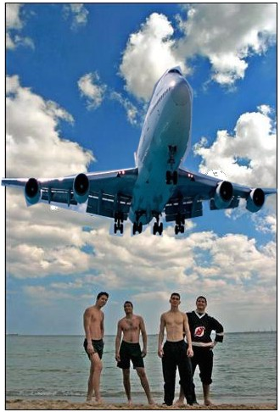

9.The Beijing 2008 logo
Use your graphics package to create a copy of the Beijing 2008 Olympics logo (copy from the internet) or create your own design to be used for the Beijing 2008 Olympics.
Everything in the graphic must be created by you using your graphics package.

10.Create the Olympic logo using your graphics program in the correct colours and layout, including links. (you must draw this yourself)

The five Olympic rings in correct colour and layout

Insert your logo here:

Insert your logo here:


END OF QUESTIONS
Check that you have typed your Student Name on the front cover of this document, and save it to your marking folder

